**Name - Gaurang A Raorane Roll No - 49**

**Class - D15A Batch - C**

**EXPERIMENT NO - 3**

**Aim:-** Experiment to study basics of CSS.

**Theory:-**

Basics of CSS: Cascading Style Sheets (CSS) is a stylesheet language used to control the presentation and layout of web documents, including HTML documents. CSS allows you to define styles for elements such as fonts, colors, spacing, and positioning, making it an essential part of web design. Here are some basics of CSS:

* **Selectors:** Selectors are used to target HTML elements to apply styles. They can target elements by tag name, class, ID, or other attributes.
* **Properties:** Properties are the specific style rules you want to apply to selected elements. Examples include color, font-size, margin, padding, etc.
* **Values:** Values are assigned to properties to specify how the style should be applied. For example, font-size: 16px;, where 16px is the value.
* **Declaration:** A declaration is a combination of a property and its value, separated by a colon and terminated by a semicolon. Multiple declarations are separated by semicolons.
* **Rule:** A CSS rule consists of one or more declarations enclosed in curly braces {}. It defines how an element should be styled.
* **Selector Specificity:** Specificity determines which styles are applied when multiple conflicting rules target the same element. Specificity is calculated based on the type of selector and its components.
* **Cascading:** The "C" in CSS stands for "Cascading," which means that styles can be inherited from parent elements, but they can also be overridden by more specific styles.

Ways to Include CSS in HTML:

* **Inline Styles:** You can apply styles directly to individual HTML elements using the style attribute. For example:

<p style="color: blue;">This is a blue text.</p>

* **Internal Stylesheet:** You can include CSS within the <style> element in the <head> section of an HTML document. For example:

<head>

<style>

p {

color: red;

}

</style>

</head>

* **External Stylesheet:** You can create a separate .css file and link it to your HTML document using the <link> element. For example:

<head>

<link rel="stylesheet" type="text/css" href="styles.css">

</head>

**Types of CSS Selectors:**

* **Type (Tag) Selectors:** Target elements based on their HTML tag name. For example:

p {

color: blue;

}

* **Class Selectors:** Target elements with a specific class attribute. Preceded by a period (.). For example:

.highlight {

background-color: yellow;

}

* **ID Selectors:** Target a single element with a specific ID attribute. Preceded by a hash (#). For example:

#header {

font-size: 24px;

}

* **Descendant Selectors:** Select elements that are descendants of another element. For example:

ul li {

list-style-type: square;

}

* **Child Selectors:** Select elements that are direct children of another element. For example:

ul > li {

font-weight: bold;

}

* **Pseudo-classes and Pseudo-elements:** These selectors target special states or parts of elements. For example:

a:hover {

color: red; /* Styles a link on hover */

}

p::first-line {

font-weight: bold; /* Styles the first line of a paragraph */

}

**Input:-**

Index.html

<!DOCTYPE html>

<html lang="en">

<head>

<meta charset="UTF-8">

<meta name="viewport" content="width=device-width, initial-scale=1.0">

<link rel="stylesheet" type="text/css" href="styles.css">

<title>Shopping Website</title>

</head>

<body>

<header id="header">

<h1>Welcome to Our Shop</h1>

<nav>

<ul>

<li><a href="#">Home</a></li>

<li><a href="#">Products</a></li>

<li><a href="#">Contact</a></li>

</ul>

</nav>

</header>

<section class="featured-products">

<h2>Featured Products</h2>

<div class="product">

<img src="./How-modern-dairy-products-are-replenishing-the-dairy-market-in-India-1-1130x580.jpg" width="200" height="200" alt="Product 1">

<p class="product-name">Dairy Products</p>

<p class="product-price">$19.99</p>

</div>

<div class="product">

<img src="./Mondelez-Philippines-snacks-3-edited.png" height="200" width="200" alt="Product 2">

<p class="product-name">Snacks</p>

<p class="product-price">$24.99</p>

</div>

</section>

<footer>

<p>&copy; 2023 Shopping Website</p>

</footer>

</body>

</html>

Styles.css

/* External Stylesheet (styles.css) */

/* Type (Tag) Selector */

body {

font-family: Arial, sans-serif;

background-color: #f0f0f0;

margin: 0;

padding: 0;

}

/* ID Selector */

#header {

background-color: #333;

color: white;

text-align: center;

padding: 20px;

}

/* Class Selector */

.product {

border: 1px solid #ccc;

background-color: white;

padding: 10px;

margin: 10px;

text-align: center;

}

.product-name {

font-weight: bold;

}

.product-price {

color: #007acc;

}

/* Descendant Selector */

nav ul {

list-style: none;

padding: 0;

}

nav ul li {

display: inline;

margin-right: 20px;

}

/* Pseudo-class */

nav ul li a:hover {

color: #ff6600;

}

**Output:-**

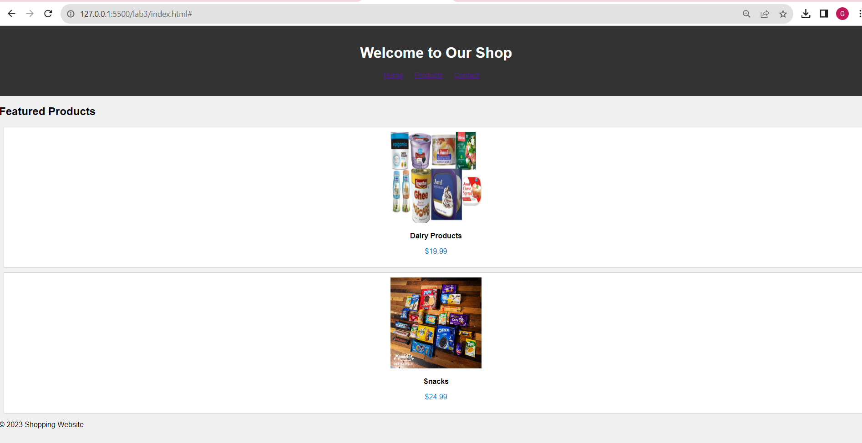

**Conclusion:-**